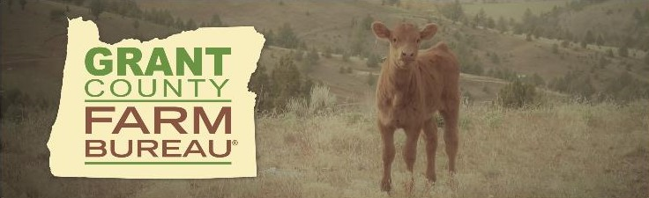GRANT COUNTY FARM BUREAU

Dan Driscoll Memorial Youth Scholarship

Application Deadline June 1st, 2025

Grant County Farm Bureau is pleased to assist the youth of Grant County in pursuing

further education. We award scholarships annually and a Farm Bureau student membership to each recipient.

ELIGIBILITY:

1. Current or former Grant County resident.
2. Enrollment or acceptance at an accredited school of higher education in a natural resource or agricultural/industrial/business related field of study.
3. Two years high school participation in 4H/FFA, other agricultural or industrial arts related organization.
4. Full-time (minimum 12 credits or units per quarter or term) course of study).

APPLICATION REQUIREMENTS:

1. Evidence of eligibility requirements.
2. Demonstrated relationship between student’s major field of study and agriculture.
3. Two letters of recommendation; one from an unrelated teacher and the second from an unrelated adult.
4. Completed, signature application form. Incomplete or untimely applications will not be accepted.
5. Official transcript from most recent school attended.

PROCEDURE:

1. Applications and supporting materials submitted by June 1st, 2025.
2. A personal interview may be held with applicants by the selection committee.
3. Selection committee will select and notify awardees by June 30th, 2025. Funds will be dispersed directly to the awardees’ school following the student’s successful completion of their first term/semester and proof of continued enrollment.
4. Applicants receiving a scholarship will be invited to attend and speak or submit a written update at the annual meeting of the Grant County Farm Bureau, generally held in September.

For more information contact Charlene Morris, Grant County Farm Bureau President; [GCFarmBureau@outlook.com](mailto:GCFarmBureau@outlook.com) or 541-379-8190.



Grant County Farm Bureau

Dan Driscoll Memorial Scholarship Application

Application deadline: June 1st, 2025

Return to: Grant County Farm Bureau

60016 Hwy 26

John Day, OR 97845

electronic applications preferred; email to GCFarmBureau@outlook.com

|  |  |  |
| --- | --- | --- |
| Applicant Name: |  |  |

|  |  |  |  |
| --- | --- | --- | --- |
| Address: |  | Phone: |  |
|  |  | Email: |  |
|  |  | Birthdate: |  |

|  |  |  |  |
| --- | --- | --- | --- |
| School where enrolled or accepted |  | # of Credits |  |
|  |  |  |  |
| List school(s) attended (include date(s) of graduation) |  | Cumulative GPA |  |
|  |  |  |  |
|  |  | SAT/ACT Scores |  |

|  |  |
| --- | --- |
| Current Major or Field of Study |  |
|  |  |
| Describe how your current course of study relates to or benefits agriculture |  |
|  |  |
| Recognition, Honors and Awards |  |
|  |  |
| School Activities |  |
|  |  |
| Community Activities |  |
|  |  |
| Organizational Memberships & Activities |  |
|  |  |
| Leadership Experience |  |
|  |  |
| Work Experience |  |
|  |  |
| Volunteer activities |  |

Are you or your family members of Farm Bureau? _______

How did you learn about this scholarship? ____________________________________________

Signature of Applicant____________________________________ Date:___________________

* Additional sheets may be attached.