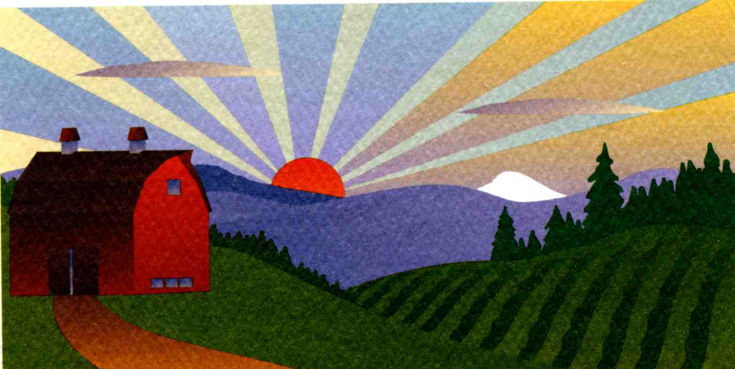
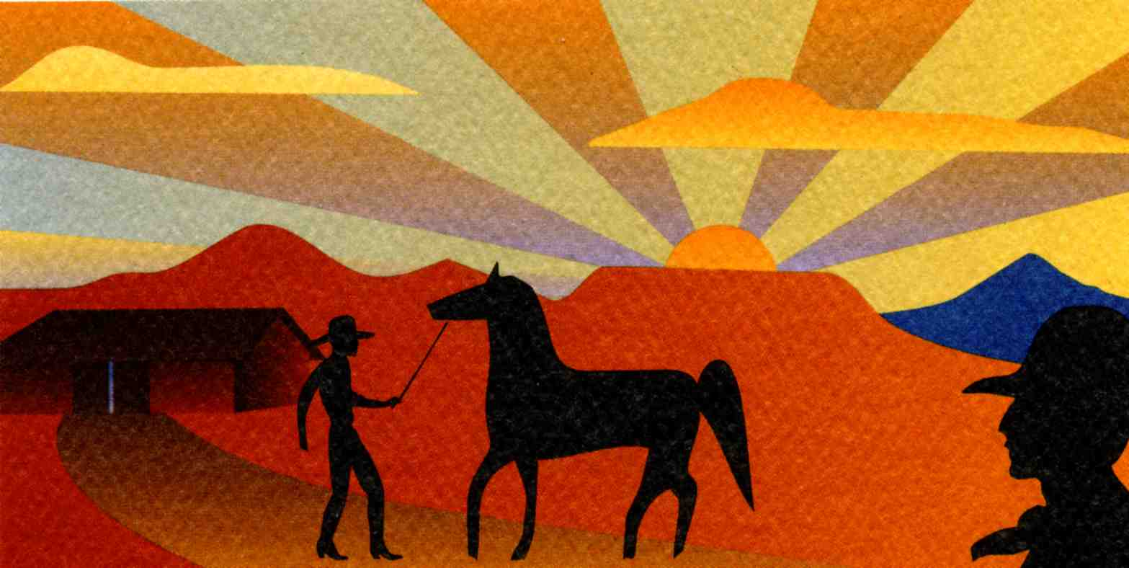
Oregon Century Farm & Ranch Program

A program of the Oregon Agricultural Education Foundation
SESQUICENTENNIAL AWARD 150 YEARS
Application Guidelines

Background_______________________________________________________________________
The Century Farm & Ranch Program is a nonprofit, volunteer-led program to honor farm and ranch families with century-long connections to the land and recognize Oregon’s rich agricultural heritage. The program is administered through the Oregon Farm Bureau Foundation for Education and is partially funded through a partnership with the Oregon Farm Bureau, the State Historic Preservation Office, Oregon State University Libraries’ Special Collections & Archives Research Center, and community members throughout Oregon.

In 2008, a Sesquicentennial Award recognizing families who have sustained their family-ownership of an Oregon farm or ranch for 150 years or more was introduced. This new award is an outgrowth of the Oregon Century Farm & Ranch Program that began in 1958 on the eve of the Oregon statehood centennial.

All applications are added to the OSU Libraries’ Special Collections & Archives Research Center. They provide valuable information about settlement patterns, livestock and crop choices, building design and family history. Successful applicants receive a distinctive certificate, with acknowledgement by the governor of Oregon and the director of the Oregon Department of Agriculture and metal roadside sign with special Sesquicentennial nameplate identifying their Sesquicentennial Farm or Ranch at a special awards ceremony at the Oregon State Fair.

Qualifications___________________________________________________________________________
- Only the legal owner(s) of the property may apply for the Sesquicentennial Farm or Ranch status.

- The farm or ranch must have been operated continuously in the same family for 150 years or more. A farm or ranch settled any time 150 years ago or earlier will be eligible if it meets other requirements.

- The farm or ranch must have a gross income from farming or ranching activities of not less than $1,000 per year for three out of the five years immediately preceding the application.

- If living off the farm or ranch, or if the farm or ranch has ever been rented or leased, the owning family must actively manage and direct the farming or ranching activity on the land. Contact 503-400-7884 or cfr@oregonfb.org if you have any questions about eligibility.

- The line of ownership from the original settler or buyer may be through children, siblings, or nephews and nieces. Adopted children will be recognized equally with other descendants.

- Applications must be submitted on forms provided by the Century Farm and Ranch Program with all questions completed. Applicants must submit a narrative of family history, two to three pages in length that adds to the information included in the application. Copies of historical and current photographs of the farm or ranch and family are encouraged. All information, including photos, will be deposited in the OSU Libraries’ – Special Collections & Archives Research Center for future reference. Please do not send in original photos and/or documents, as all items sent with your application are NOT returned. Please send in quality copies of documents that support your application. Applications should include 4-5 digital photos from your application and sent to cfr@oregonfb.org by May 1.

7. All applications must include verification of continuous ownership for 150 years. Acceptable forms of proof
include a document (high quality photocopy) showing date of earliest ownership. This may be provided through
a Donation Land Claim, Deed of Sale, or Homestead Certificate. Other records, subject to review, include a
family Bible, diary entry, or correspondence. In the interest of obtaining the fullest possible historical record we
ask sesquicentennial applicants whose farm has attained century status to review the materials submitted for
100-year recognition for accuracy and completeness. The Century Farm and Ranch program will provide you
copies of that application. Please note that sufficient and clear documentation from the beginning of the farm or
ranch must be provided for sesquicentennial recognition, not just documentation from century status forward.

8. Applications must be signed and certified by a Notary Public.

9. Deadline for returning applications is May 1 of the current year and must be postmarked by midnight.

Researching Farm and Ranch History
The Oregon Century Farm & Ranch Program website has tips on gathering information about farm and ranch history. The website is located at www.centuryfarm.oregonfb.org.

Completing the Application
This application is a Word document. You can fill information in as you answer the questions. You may notice the page adjusting as you enter text. That is OK. You can also submit a completed photocopy of this form.

Fees
A $400 fee is required with each application. This fee covers administrative costs and includes one certificate and one roadside sign. Additional certificates may be ordered at the time of application at $20 each and roadside signs at $315 each. Make checks payable to: OAEF with OCF&R Program in Memo Line

Where to Send Completed Application Packets
Send the completed application (including the family history narrative, map and digital photos), Statement of Affirmation, your documentation, and sign and certificate order form, with fee payment, to:
Oregon Century Farm & Ranch Program
Oregon Agricultural Education Foundation

1320 Capitol St. NE, Suite 200

Salem, OR 97301

Do not send original documents, as they will not be returned. We recommend that you make a copy of your completed application before mailing. It makes a wonderful single source of farm information for years to come.

Review Process and Notification
All applications are checked for completeness by the program coordinator and reviewed by the Program Board. All applicants will be notified about their status by July 1.

Honoring Ceremony
Successful applicants, their families and neighbors are invited to a special ceremony at the Oregon State Fair to receive the certificate. The certificate has the name of the farm or ranch and is suitable for framing.

Still Have Questions About the Program?

Contact: Andréa Kuenzi, Program Coordinator, at 503-400-7884 or cfr@oregonfb.org
Thank you for helping us preserve Oregon’s rich agriculture heritage and the important role it plays in keeping the state a healthy and vital place for Oregon residents and visitors. For more information about the Oregon Century Farm & Ranch Program visit https://www.oregonfb.org/centuryfarmandranch
A program of the Oregon Agricultural Education Foundation
Date: _________________
Sesquicentennial Award Application

Type of designation (please check one)  Sesqui. Farm  Sesqui. Ranch
Press Contact (please check one)  YES, both applicant & contact person (if different)  YES, Applicant only  NO
(This give us permission to give members of the press who request it your contact information for possible articles about your farm or ranch)
Legal owner / Applicant name _______________________________________________________________

Farm or Ranch Name (this is the name used in all publicity & marketing)

________________________________________________________________________________________

Phonetic Spelling/Pronunciation of Family Name_________________________________________________

Mailing address of Legal Owner / Applicant ____________________________________________________

________________________________________________________________________________________

Telephone ______________________________ E-mail address ___________________________________

Contact name (if different than legal owner) ____________________________________________________

Mailing address of contact___________________________________________________________________

________________________________________________________________________________________

Contact telephone _____________________ E-mail address _______________________________________

Location of farm or ranch (which is the subject of this application):

County _______________________________

Distance __________________ from nearest town _______________________________________________

Township __________________________ Range _____________________Section ____________________

Address or physical location of the farm or ranch (which is subject of this application)
________________________________________________________________________________________

(Continue application on next page)
Sesquicentennial Award Application - Continued

GPS (Global Positioning System) Coordinates, if known __________________________________________

________________________________________________________________________________________

Please attach a map or drawing showing the location of the eligible property within the context of the family farm or ranch.

Founder(s):

Original family owner(s) or founder(s) ______________________________________________________

Founder(s) prior Country or State if not Oregon _______________________________________________

Date (year) this farm or ranch was acquired by founder(s) _______________________________________
(Attach verifying documentation. See Application Qualification #7)

Who farms or ranches the land today? _______________________________________________________

Relationship of applicant to original owner. Clearly explain lineage from original ownership documents to current applicant. (See Application Qualification #7) ___________________________________________

The family:

How many generations live on the farm or ranch today?

List names and birth years:

How many acres were included in original farm or ranch? _______

How many acres are included today in the farm or ranch? _______

How many acres are in agricultural use today? _______

If the farm or ranch has ever been rented or leased, please explain the owner’s role in this relationship. For example, is the owner actively involved in the management of the land?

Year farm or ranch was awarded Century Farm or Century Ranch status, if applicable ________________

Farm Succession Family Tree:
One of the keys to a successful Century or Sesquicentennial Farm/Ranch application is a list of the family members through time that have owned your farm. This worksheet will help the OCF&R committee members to understand those changes in ownership over time.

- Original owner(s) and date farm established____________________________________

- Next family member owner name(s)__________________________________________

- Date of farm transfer to this owner_______________________________________

- Relationship to original owner (s) (brother, daughter, niece, etc.)

______________________________________________

- Next family member owner name(s)__________________________________________

  - Date of farm transfer to this owner_____________________________________

  - Relationship to previous owner(s) (brother, daughter, niece, etc.)

___________________________________________

- Next family member owner name(s)__________________________________________

  - Date of farm transfer to this owner_____________________________________

  - Relationship to previous owner(s) (brother, daughter, niece, etc.)

___________________________________________

- Next family member owner name(s)__________________________________________

  - Date of farm transfer to this owner_____________________________________

  - Relationship to previous owner(s) (brother, daughter, niece, etc.)

___________________________________________

- Next family member owner name(s)__________________________________________

  - Date of farm transfer to this owner_____________________________________

  - Relationship to previous owner(s) (brother, daughter, niece, etc.) __________________________________________
(Continue application on next page)
Sesquicentennial Award Application - Continued

- Next family member owner name(s)__________________________________________

  - Date of farm transfer to this owner_____________________________________

  - Relationship to previous owner(s) (brother, daughter, niece, etc.)

___________________________________________

History of crops or livestock raised on farm or ranch:

What were the early crops or livestock?

How did the crops / livestock / use of farm or ranch change over the years?

What are crops / livestock raised on the farm or ranch today?

History of buildings:

Are any of the original buildings still in use? Yes No

When was the first house built? If it is still in use, describe the changes that have been made.

What years were other structures built (examples: barns, silos, machine shops, coops, smokehouses, dryers, etc.). Describe the changes that have been made to them, including any demolition.

Is any part of the property on the National Register of Historic Places? If so, please explain.

(Continue application on next page)

Sesquicentennial Award Application – Continued

What are the three most important things/events that you would want someone to know about your family’s farm or ranch?

The family history narrative:
Submit two or three pages of family history narrative, including, but not limited to generational transfers of the farm or ranch. Please also submit historical & current photos of the property & family, if available. Do not send original documents as they will not be returned. Digital format photos (at highest resolution [300 dpi]) are particularly desirable, so that they may be used in publications, the program’s database or the web site. Submitted information, including photos, will be deposited in the OSU Libraries – Special Collections & Archives Research Center for future reference. Please send digital photos included with your application to cfr@oregonfb.org by May 1.

Type of information to include in your family history narrative:
- Where founder(s) may have moved from to farm or ranch
- Significant events in the family (births, deaths, marriages, etc.)
- Any major changes to operations (methods of production, etc.)
- Additional information on crops, buildings, other changes from the original farm or ranch
- Any special family farm or ranch stories you’d like to share, passing on techniques, interesting characters, & family folklore

Application Checklist-Do you have all of these items?:
- Completed Application (pgs. 3-7)
- Family Narrative (see page 7 for what is needed, 2-3 pgs. typed)
- Family Succession Tree (pgs. 5-6)
- Map of Property (pg. 4 make sure it clearly shows original property and anything added to date)
- Notary Page (pg. 8)
- Completed Sign order form (pg. 9); don’t forget to check type (ranch or farm) of Century designation
- Check for correct amount $400 for app fee + any additional Signs/certs (see pg. 8-9 sign/cert order form)
- If you or a family member are interested in serving on the OCF&R Program Management committee please check this box
(Continue application on next page)

Sesquicentennial Award Application

Statement of Affirmation
I, ___________________________________________________________________________________,
hereby affirm and declare that the farm or ranch which I own at _________________________________
___________________________, in the County of ___________________________________________
has been owned by my family for at least 150 continuous years, as specified in the qualifications for the Century Farm & Ranch Program, on or before December 31 of the current calendar year. Further, I hereby affirm that this property meets all other requirements for Century Farm or Ranch honors, including that the farm or ranch has a gross income from farming or ranching activities of not less than $1,000 per year for three out of the five years immediately preceding making this statement. I understand that the application materials will become property of the OSU Libraries – Special Collections & Archives Research Center and be made available for public use. By signing below, I understand that I am consenting to the use of both information and photographs.

Signature of Owner Date

Certification by Notary Public

State of Oregon County of _______________________________

Be it remembered, that on this ______day of _______________, 20____, before me, the
undersigned, a Notary Public in and for said county and state, personally appeared the within named ________________________________, known to me to be the identical individual described in and who executed the within instrument and acknowledged to me that ______________________________executed the same freely and voluntarily.

In Testimony Whereof, I have set my hand and affixed my official seal the day and year last above written.
__________________________
Notary Public for Oregon
My Commission Expires _________

Fees For office use only
Application Fee (includes one certificate &
Roadside sign, Note $50 of this fee is
non-refundable) $ 400.00__ Date Received ___________________________

Additional Certificates ($20 each) $ ________ Approved?  Yes  No
Additional Signs ($315 each) $_________
Total Enclosed: $_________ Authorization ___________________________
Oregon Century Farm & Ranch Program Coordinator
Make checks payable to: OAEF with Oregon Century Farm and Ranch Program in the Memo Line

2025 Oregon Century Farm & Ranch Program

Sign & Certificate Order Form
Please return with your application
In order to ensure the correct names, spelling, and date, please fill out this form and return it with your application. For more information, please contact Andréa at 503-400-7884 or cfr@oregonfb.org.

Owner’s Name: ________________________________________________________________

Shipping Address (must be street address, signs cannot be shipped to PO Box):

______________________________________________________________________________
Street Address

___________________________________________________________________________
City State Zip Code

Phone #: ________________________ Email: _______________________________________

Select One: C Sesquicentennial Farm Sign Sesquicentennial Ranch Sign

Number of Addt. Signs Ordered (1 sign included with your application fee
@ $315 (per each additional sign) _________ Addt. must be ordered at time of application)

Number of Addt. Certificates Ordered (1 certificate included with application fee
@ $20 (per additional certificate) _________ Addt. must be ordered at time of application)

TOTAL ENCLOSED $ _________

Please make your check payable to: OAEF
with Oregon Century Farm and Ranch Program in the Memo Line
______________________________________________________________________________

SIGN NAME PLATE INFORMATION

The standard size name plate, which attaches to the sign, is 24” x 6” and can accommodate one line of 16 characters maximum for the name (the spaces between words count as characters) and the date for the second line. You may use either the historic name of the farm or ranch or the current name.

Example: Mason Farm
1892

YOUR INFORMATION:

Farm/Ranch Name: _______________________________________________________
Maximum of 16 characters, including spaces for this line only

Date Founded: _______________________________________________________
Date only no text

